**ASSIGNMENT 1**

**AVANI SHAJI KRISHNA**

**22BTRAD007**

**CSE-AI&DE**

1. Write a Scala program to print "Hello, world" and version of the Scala language.

**CODE:**

object HelloWorld {

def main(args: Array[String]): Unit = {

println("Hello, world!")

println("Scala language: "+util.Properties.versionString)

}

}

**OUTPUT**

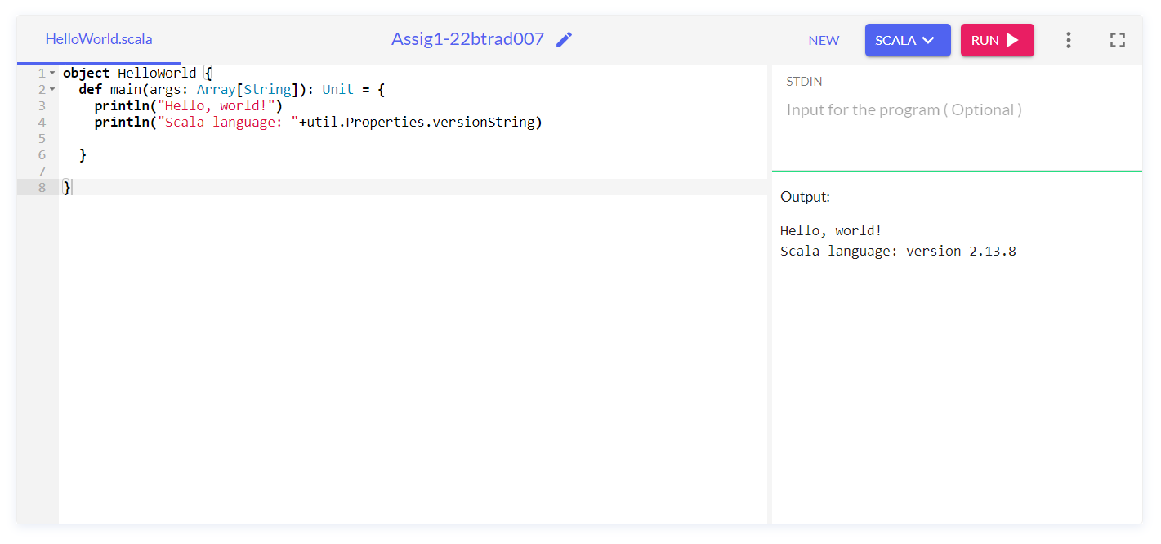

**ANOTHER METHOD**

**CODE:**

object Hello extends App {

println("Hello, world")

println("Scala language: "+util.Properties.versionString)

}

**OUTPUT:**

